Multiple-choice section

|  |  |  |  |  |  |  |  |  |
| --- | --- | --- | --- | --- | --- | --- | --- | --- |
| Question | 1 | 2 | 3 | 4 | 5 | 6 | 7 | 8 |
| Answer | A | C | A | C | B | B | C | B |

Question 1 [4.6] [10A]

A

ax2 +bx + c  
= x2 – 2x + 5

a = 1, b = -2, c = 5

Question 2 [4.5] [10A]

C

6x2 – x – 15

= 6x2 – 10x + 9x – 15

= 2x(3x − 5) + 3(3x − 5)

= (2x + 3)(3x – 5)

Question 3 [4.6] [10A]

A

x = 7 and x = -0.5

x – 7 = 0 and x + 0.5 = 0

(x – 7) and (2x + 1) are factors

(x – 7)(2x + 1) = 0

Question 4 [4.6] [10A]

C

(2x – 3)(4x + 5) = 0

As each factor can be equated to 0, the null factor law is the quickest way to solve this equation.

Question 5 [4.2]

B

x2 + 6x + 2

= x2 + 6x +  –  + 2

= x2 + 6x + 9 – 9 + 2

= (x + 3)2 – 7

= (x + 3 +  )(x + 3 – )

Question 6 [4.4]

B



Question 7 [4.3]

C

By completing the square:



Question 8 [4.4]

B

The equation is in turning point form y = (x – h)2 + k where the turning point is located at (h, k).

The turning point is (-7, -5).

Multiple-choice total marks: 8

Short answer section

Question 9 9 marks [4.1, 4.3]

**(a)** *x*(*x* + 5) = 0

*x* = 0 or *x* + 5 = 0

*x* = 0 or -5

**(b)** (*x* + 3)(*x* – 2) = 0

*x* + 3 = 0 or *x* – 2 = 0

*x* = -3 or *x* *=* 2

**(c)** 121 – 64*x*2 = 0

(11 – 8*x*) (11 + 8*x*) = 0

11 – 8*x* = 0 or 11 + 8*x* = 0

8*x* = 11 or -8*x* = 11

*x* = 

**(d)** *x*2 + 3*x* – 1 =0

(*x*2 + 3*x* + ) –  – 1 = 0

(*x*+ )2  – = 0

(*x*+  – )(*x*+  +) = 0

*x*+  –  = 0 or *x*+  + = 0

*x*= -  +  or *x*= -  – 

*x*= -   

Question 10 4 marks [4.2]

**(a)** *x*2 – 3*x* – 28



**(b)** *x*2 – 28 = 3*x*

*x*2 – 3*x* – 28 = 0

 = 0

*x* =-4, 7

Question 11 6 marks [4.2, 4.3, 4.4]

**(a)** *y* = *x*2 + 10*x* + 25 + 8 – 25   
*y* = (*x* + 5)2 – 17

(b) Turning point is (-5, -17).

Question 12 6 marks [4.1]

|  |  |
| --- | --- |
| **(a)** *x*2 + 5*x* − 14 = (*x* + 7)(*x* − 2)  **(b)** Dimensions = *x* + 7 or *x* – 2 *x* + 7 = 13 *x* = 6 *x* − 2 = 4  Length = 13 cm, width = 4 cm *x* − 2 =13 *x* = 15  15 + 7 = 22  Length = 22 cm, width = 13 cm | **(c)** Area = *LW*  For *x* = 6  Area = 13 × 4  = 52 cm2  For *x* = 15  Area = 22 × 13  = 286 cm2 |

Question 13 6 marks [4.2, 4.3, 4.4]

**(a)** *x*2 + 4*x* – 2  
= *x*2 + 4*x* + 4 – 6  
= (*x* + 2)2 – 6

**(b)**(-2, -6)

**(c)** *x-*interceptswhere *y* = 0:

(*x* + 2)2 – 6 = 0

(x + 2 + )(x + 2 − ) = 0

x = -2 

x-intercepts: (-2 + , 0) and (-2 − , 0)

Question 14 4 marks [4.6] [10A]

**(a)** *x*2 + *x* + 7 = 0x = =  ** cannot be evaluated, so there are no solutions*.*

**(b)** 2*x*2 – 5*x* – 12 = 0  *x* = =   
** can be evaluated, so there are solutions*.*

Question 15 3 marks [4.2]



Question 16 4 marks [4.6] [10A]

Area = (2*x* + 1)(*x* + 1)

45 = 2*x*2 + 3*x* + 1

2*x*2 + 3*x* – 44 = 0

(2*x* + 11)(*x* − 4) = 0

*x* *=* -5.5 or *x* = 4

Reject *x* *=* -5.5 as this will give negative dimensions.

Length = 2*x* + 1 = 9 m

Width = (*x* + 1) = 5 m

Question 17 6 marks [4.4]

**(a)** *y*-intercept is (0, -10),   
*y* = (*x* – 5)(*x* + 2), so the *x*-intercepts are (-2, 0) and (5, 0).

**(b)** *y*-intercept is (0, -64),   
*y* = (*x* – 8)(*x* + 8), so the *x*-intercepts are (-8, 0) and (8, 0).

Question 18 3 marks [4.4]

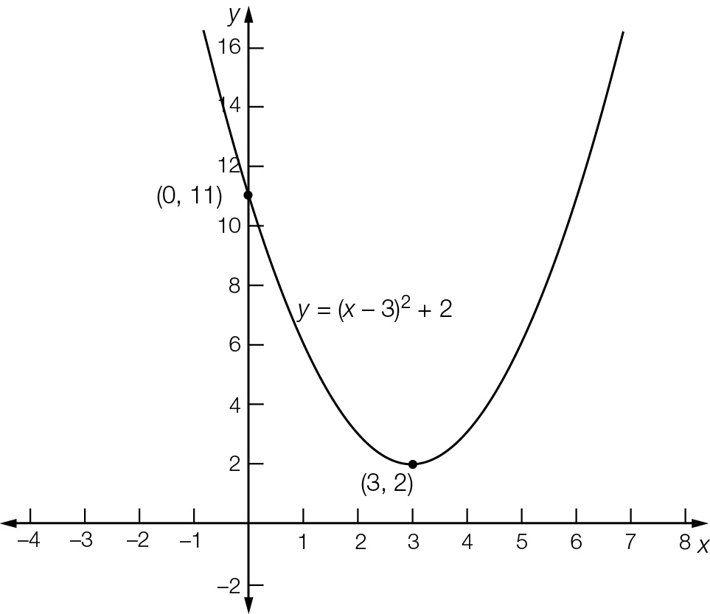

Question 19 3 marks [4.4]

Turning point is at (*h, k*) = (4, 6)

So 

For *x* = 6

26 = *a*(6 – 4)2 + 6



Short answer total marks: 54

Extended answer section

Question 20 6 marks [4.4]

(a)

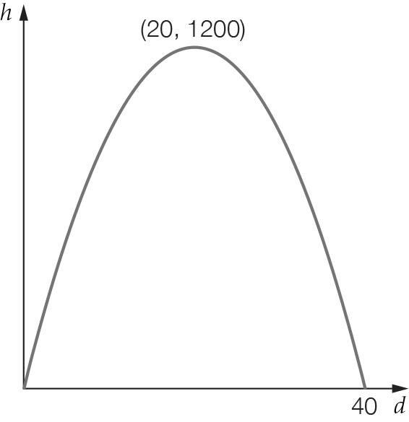

**(b)** Maximum height at turning point (20, 1200) = 1200 m

**(c)** Where *y* = 0:   
-3(*d* – 20)2 + 1200 = 0  
(*d* – 20)2 – 400 = 0  
(*d* – 20 + 20)(*d* – 20 − 20) = 0  
*d*(*d* – 40) = 0   
*d* = 0 or 40  
Distance to target is 40 km.

Question 21 6 marks [4.1]

**(a)** Area = 

**(b)**   


**(c) (i)**   


**(ii)**  but x must be ≥ 2*r*

Therefore the shaded area can never be zero. A circle cut from a square will always leave waste.

Question 22 9 marks [4.2, 4.3, 4.4]

(a)

|  |  |  |  |  |  |  |  |
| --- | --- | --- | --- | --- | --- | --- | --- |
| x | 0 | 1 | 2 | 3 | 4 | 5 | 6 |
| y | 0 | 5 | 8 | 9 | 8 | 5 | 0 |

(b)

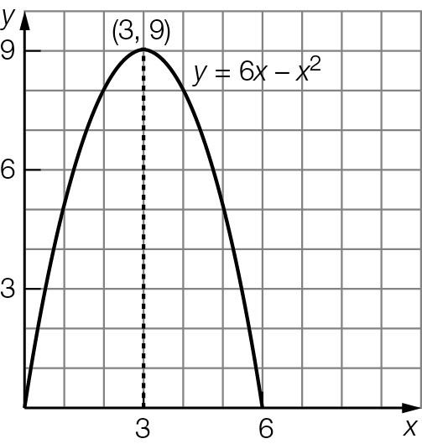

**(c)** (3, 9)

**(d)** *x-*intercepts are (0, 0) and (6, 0), *y-*intercept is (0, 0).

**(e)** 6*x* – *x*2 = 6  
*x*2 – 6*x* + 6 = 0   
*x*2 – 6*x* + 6 = 0   
*x2* – 6*x* + 9 – 3 = 0  
(*x* – 3)2 – 3 = 0  
*x* = 3 ± 1.73  
 = 1.27 or 4.73  
Check: 6 × 1.27 – 1.272 = 6.0, and 6 × 4.73 – 4.732 = 6.0  
The ball was at a height of 6 m, 1.27 seconds and 4.73 seconds after the ball was thrown.

**(f)** There are two times, one when the ball was on the way up and the other when the ball was on the way down.

(**g)** The ball reaches a maximum height of 9 m. It does not reach the 12 m level so there are no times when this happens.

Question 23 4 marks [4.4]

The highest level is the *k*-value of the turning point. In turning point form:

*h* = -*x*(*x* – 5)

= -(*x*2 – 5*x*)

= -(*x*2 – 5*x* + 6.25) + 6.25

= -(*x* − 2.5)2 + 6.25

So the height reached is 6.25 m.

Extended answer total marks: 25

TOTAL test marks: 87